An interpretative phenomenological analysis of trauma focused counsellor’s experience of working with survivors of sex trafficking.
Karen Foran, BA, M.Sc., M.Sc., PhD Student.
k.foran@edu.salford.ac.uk
karenforancounselling.com
Introduction & Background
The UK is a destination country for trafficking for sexual exploitation with numbers increasing each year (Unseen, 2019). Due to such vast numbers entering the UK it is highly likely that support services will come in contact with survivors of sex trafficking. The impact of trauma on survivors of sex trafficking requires specialist therapeutic interventions. With such presentation of trauma symptoms, it is important that counsellors who work with sex trafficked clients are trauma informed and competent, to ensure positive outcomes for
clients, but also an awareness of the impact of the work on themselves.

Aim and Purpose
The aim of this study was to explore the trauma counsellor’s lived experience of working survivors of sex trafficking and to assess the psychological impact on trauma counsellors who work with this client group.
It was hoped that the gathering of such information would enable trauma counsellors to
monitor their own responses when working with survivors of sex trafficking, that can help towards their own well-being and self-care and acknowledge the importance of supervision.

Design/Methodology
Three trauma counsellors were recruited who had experience of working with sex trafficked clients.
Data was collected through semi-structured interviews conducted using the online video
platform Zoom.
Data was analysed using interpretative phenomenological analysis.

Results/Findings
Four super-ordinate themes were identified, the complexities of client/counsellor
relationships, the overwhelming thirst for knowledge, the palpable nature of trauma, the essence of support and what that looks like.
The study identified clinical implications to develop further understanding and requirements
for trauma focused counsellors who work with sex trafficked clients.
Highlighted vicarious trauma, learning, training, and support that can assist future trauma
counsellors working with survivors of sex trafficking.
Table 1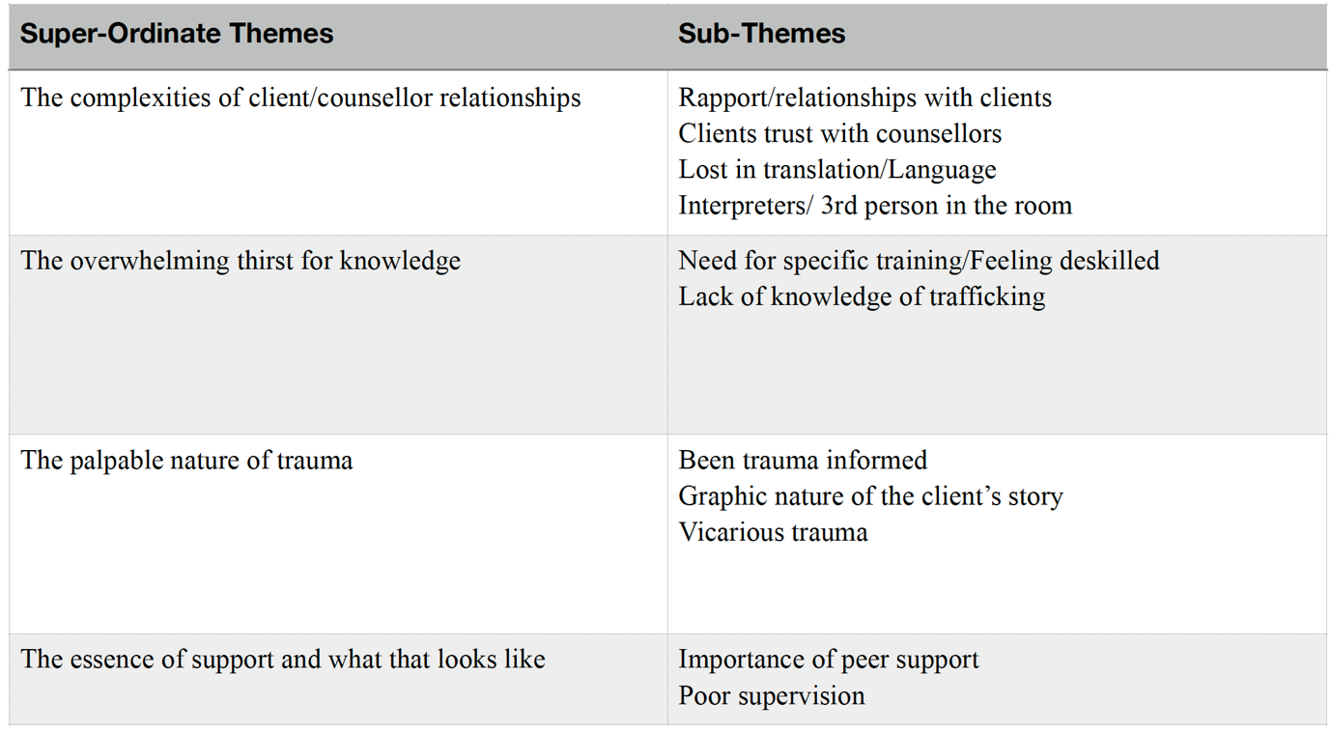

Limitations and Conclusions
Small sample of trauma therapists who work with this client group, were known to the researcher. It could be argued that due to this relationship between the participants and the researcher it could create bias which could have potentially impacted the findings.
In contrast, this it could also create a more robust piece of research due to established relationships, rapport and a sense of familiarity that may have put the participants at ease when discussing such difficult content.
Future research could address the sex trafficked survivor’s experience of receiving counselling, which would be valuable to teaching and training in order to ensure this client group receive support for the best therapeutic outcomes.

The Author
Karen Foran is a psychotherapist, clinical supervisor and PhD student based in Manchester. Karen would like to thank her thesis supervisor for this research Dr India Amos and her current PhD supervisors Dr Laura Viliardos and Dr India Amos, University of Salford.
For further enquiries regarding references & this study please use the QR code below.

